How to Link Apple Business Connect Account with Yext

Apple delegation is currently only available for customers with 25 or more locations.

Linking your Apple Business Connect account with Yext allows you to update your Apple Maps listing information, view Apple analytics, and create Apple Showcase social posts directly from Yext.

Note: The creation of entities within the client ABC (assuming they are delegated) and the downstream matching to existing or creating new listings on Maps will all happen automatically

Note: The ability to link your Apple Business Account is only available for customers with 25 locations or more.

To link your Apple Business Connect account with Yext:

Step 1: Create Apple Business Connect Account

- Create an Apple Business Connect Enterprise account directly with Apple by visiting https://businessconnect.apple.com/.
  - For full steps to create an enterprise account, visit the Create your enterprise account in Apple Business Connect help article on the Apple Support site.
  - It can take up to 5 days for Apple to verify your account.
    - Note: For companies based outside of the US, if you can’t find your DUNS number, visit Dun & Bradstreet Global Reach to choose your country and look up or obtain your DUNS number. For further assistance with obtaining your DUNS number or verifying your account, contact Apple Support.
  - You can use any email address to create an Apple ID. If you don't have an existing Apple ID, or if you only have a personal Apple ID that you don't want to connect with Apple Business Center, you can set up an Apple ID using your corporate email.

- Once the account is created and verified you will need to create businesses for the account at the country level. A new business folder is required for each country and each sub-brand that you want to have under the same Apple account. Yext will automatically add your locations to your Apple account, once the delegation process has been completed. So, you don’t need to add each location individually. Once the businesses are created, you should not claim your own locations. This process is done automatically by Yext, once the account linking process is complete. Claiming your own locations will prevent us from syncing locations.
- Click on the Businesses tab in the sidebar.
- Click Add in the top right corner, and create the relevant businesses for each country.
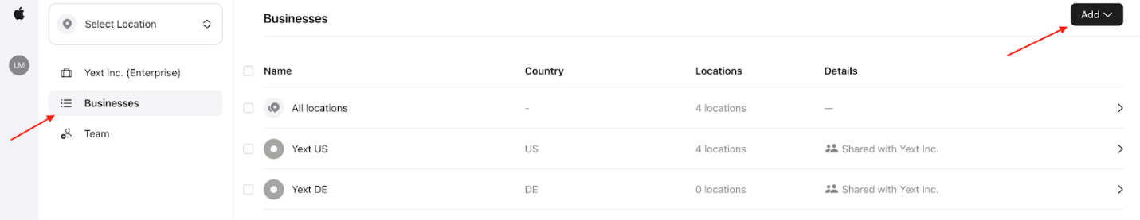

- Once the businesses have been added, click on the company name in the sidebar.
- From the company level page, click on the Shared tab. Then click on the Share access link. A dialog box appears.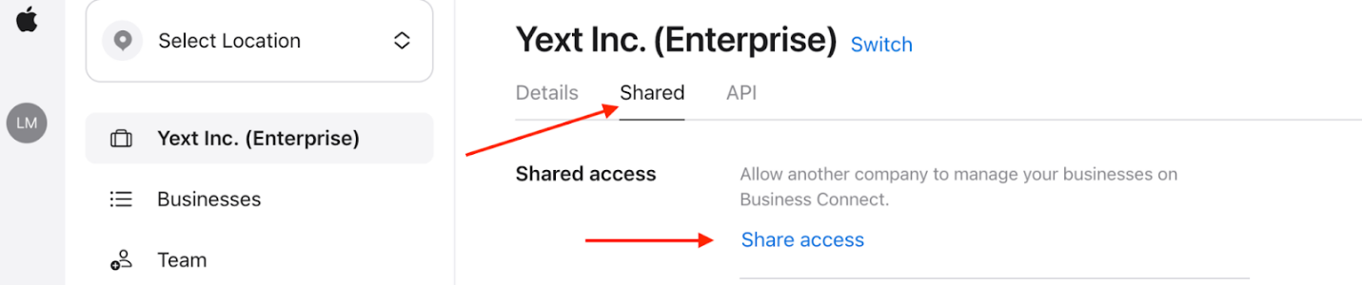
- In the dialog box that appears, you will need to enter the Yext Partner’s Company ID: 1452435188350445568.
- Ensure that the Business Role is set to Admin.
- Click on the Access drop-down, and select either All Businesses, or specify the specific businesses to delegate.
  - Note: If a new business is created after going through these steps, you will need to go through the steps again to grant access to the new business, even if All Businesses was originally selected.
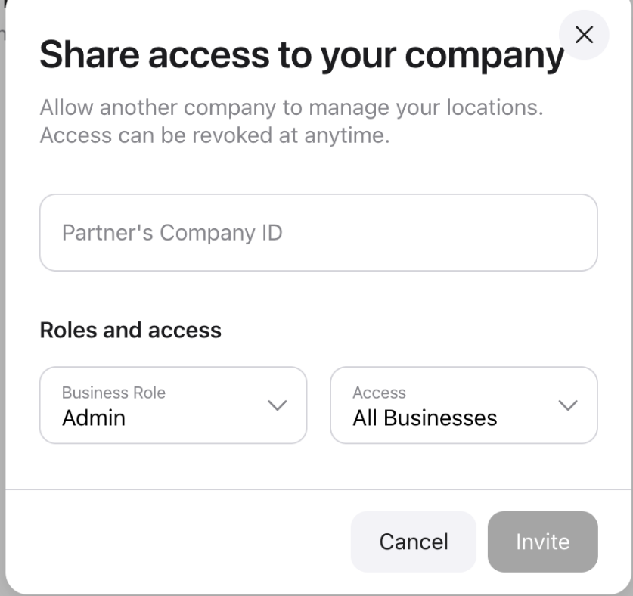
- Click Invite to send the delegated businesses to Yext.
  - Once Yext has accepted the invite, the businesses are officially delegated to Yext as an agency in the Business Connect account.

Step 2: Specify Apple Account Details in Yext Content

Once you have linked your Apple Business Connect account with Yext, you must specify your Apple Business ID fields in Yext Content for each entity that you wish to sync to Apple.

Retrieve your Apple Business ID
Your Apple Business ID can be found within your Business Connect Account. The Apple Business ID is specific to each business and country combination within the Company account. In order to find the Business ID, you should first select the specific business and country you wish to enable on Yext.
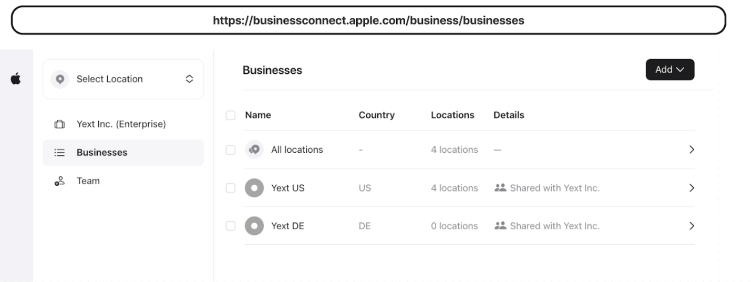

Once you have selected the Business you can find the Apple Business ID in the browser URL. The number following “orgs/” is your Apple Company ID, this will automatically be populated in Yext when you link your account. The number following “businesses/” is your Apple Business ID. This is what you need to add to Yext.

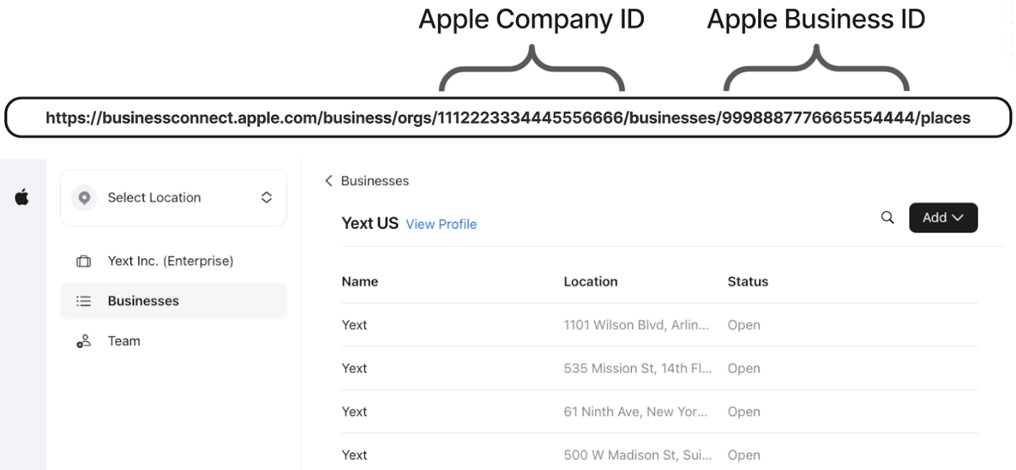

Add the relevant IDs to the entities in Yext Content
- From within your Yext account, click Content in the navigation bar, and click Entities.
- Bulk edit any entities you want to include in the delegation, and create Showcase posts on. For more information about bulk editing, see Edit Entities in Bulk.
- Add your Company ID to the Apple Company ID Field.
- For each individual brand folder in your Apple Business Connect, add the Business ID to the Apple Business ID field.

Once this is done, delegation is complete account-wide and you can take advantage of all Apple-related features through Yext.

Note: If the Apple Company and Apple Business IDs are not uploaded to Yext within 30 days after approval, access is lost and you will need to remove and reshare access with Yext.

Deleting Locations and Accounts

Please exercise extreme caution when deleting any locations or accounts in Apple Business Connect. Deleting a Yext-powered location in Business Connect will remove the ability for Yext to sync to the location. In addition, reinstatement cannot be guaranteed by Apple if an Apple Business Connect account is deleted.

